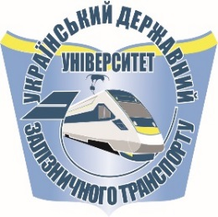 | 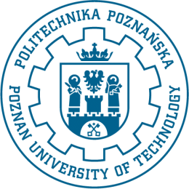
APPLICATION FORM FOR ADMISSION TO
Double Master’s Degree Programme – 2018/2019
NOTE! Application form should be filled in by computer printed, signed and sent to:
study@put.poznan.pl and cms@kart.edu.ua

PERSONAL DETAILS :
SURNAME: ……………………….………………..…… FIRST NAME(S)…………………………………………………………………….
Gender: male female Date of birth: ......./……..…/………. Place of birth ………………………………………………………..
day / month / year
Father’s name: ……………………….……………….……. Mother’s name: ………………………….…………………...…………………..
Citizenship: ………………………………… Nationality: …………………………………………….
Passport ……………………...or National Identity Card number: .…….………………… Expiry date : ……………………….…………...

Permanent address: ……………………………………………………………………………………………………………….........................

street / number / zip code / city / country
E –mail address: ……………….…………………….………………………………………………………………………………………………
EDUCATIONAL BACKGROUND
Education completed: secondary No of secondary school certificate: ……………………… issued on : ....../…….…/…….….,
day / month / year
by: ………………………………………………………….…………………………………………………
higer No of diploma: …………………………… issued on : ……../………/……….,
day / month / year
by: ……………………………………………………………………………………………………………

INTENDED PROGRAMME OF STUDY : .............................................................................................................................................
..............................................., ........................... ...............................................................
(place) (date) (signature)

